OUTREACH SCHOOLS EXAMINATION BOARD
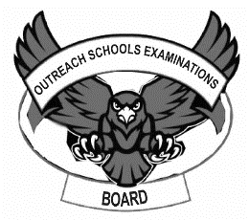
BEGINNING OF TERM III EXAMINATION 2023
PRIMARY ONE
MATHEMATICS

My name is _____________________________________________

I am in _________________________________________________

My school is ____________________________________________

SECTION A:
- Add: 1 + 3 =

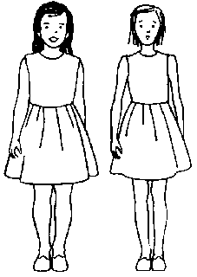
- Name this set.

A set of __________________ girls.

- Count and write the number.

= _______________________
- Fill in the missing counting numbers.
1 , 2 , 3 , _____ , 5 , _____ , 7

- Shade 
- Take away:
8 - 3 = ________

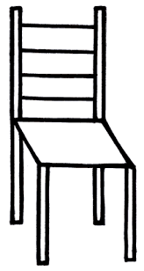
- Join these sets.
+ =

- Draw tens and ones for ;

12 = ______________________________________________________
- Write in words.
7 = ____________________________________________________
- One rabbit has 2 ears. How many ears do 3 rabbits have?

___________________________________________________
- Name the shape below.

Square , Triangle
_________________

- Which counting number comes before 15?
_______ , 15
- Draw a set of four balls.

- Which pot is bigger?
Pot K
Pot R
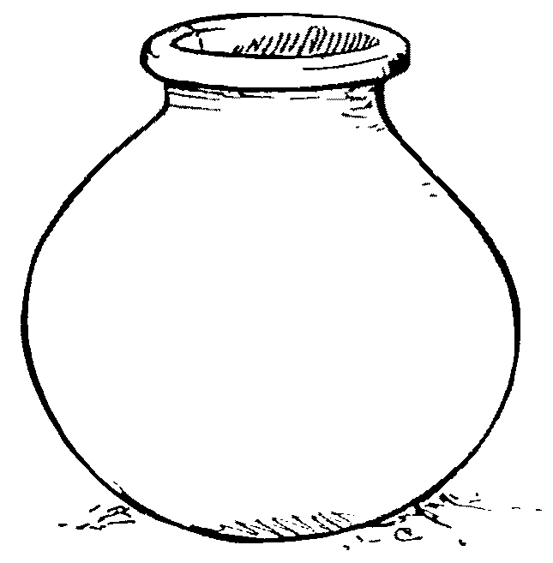

___________________________________
- Arrange the numbers beginning with the smallest.
6 , 4 , 9 = _____________________________________
SECTION B
- Complete the abacus.
T O
4 2 = __________
T O
- b)

= ___________

- Name the shapes below
S
Y
T

S is a _______________________

Y is a ________________________

T is a _________________________
(rectangle , circle , triangle)

- Sarah has 9 dresses. Betty has 7 dresses.
- Who has more dresses?
______________________________________________________
- Who has less dresses?
_____________________________________________________
- How many dresses do they have altogether?

_____________________________________________________
- Work out: c) 2 x 3 = ______
- 2 4 b) 6
+ 1 3 - 5

- Match correctly.
Ninety 19
Nine 90
Nineteen 9
- Fill in tens and ones.
- 7 = _____________ tens __________ ones.
- 93 = ____________ tens _________ ones.
- _______ = 5 tens 4 ones.
- Match correctly.
a quarter
 a third
 a half
- Study the picture graph and answer the questions.
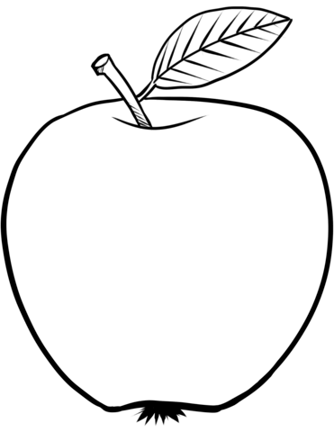
Sam
James
Alvin

- How many children were given apples?
______________________________________________________
- Who got the highest number of apples?
______________________________________________________
- How many apples were given altogether?

END

